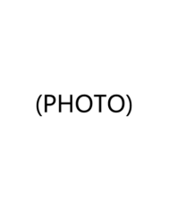
Education

HONORS
Honors

Skills

Experience

2002.09-2006.06 Shanghai Maritime University B.Eng., Marine Engineering
- Bachelor's degree in Marine Engineering

Li Jiajun

Personal Resume

Rm8542, B2, 15 Beihuqu Rd., Beijing
08 Dec 1983

Phone: +86-13761058893
E-mail: jiajun.li@audi.com.cn
- N/A

- Certified VDA 6.3 and VDA 6.8 Auditor
- 20 years of supply chain management, supplier audit and risk mitigation experience
简历

2022.05-Present | Audi China Enterprise Management Co., Ltd. | Supply Chain Planner
2006.07-2022.05 | SAIC Volkswagen | Expert of Supply Chain Management
- Audi China: Global supplier qualification; strategic supplier development and maturity assessment.
SAIC Volkswagen: Supply chain risk prediction and mitigation; risk framework development.

